System Requirement

Specification

*–*

**Document ID:** ASP-OSS-SRS-02.doc

### Author(s): ASFAQ AHMED M

**Version:** 0.2

**Date: March** 15, 2023

**Confidential 1**



**Copyright notice:** Copyright © 1996-2004 Aspire Systems. All rights reserved. The contents on this document are not to be reproduced or duplicated in any form or kind, either in part or full, without written consent from Aspire Systems.

1. Objective and Scope 3
2. Abstract 3
3. Overall Description 3
   1. Module Requirements 3
   2. Functional Description 3
4. Use Case Diagram 4
5. Flow Chart Diagram 5
6. Class Diagram 6
7. ER Diagram 7

# Objective and Scope

The objective and the scope of the project is to build an online shopping system that can sell products to the user through online.

The scope of the product includes the following basic features:

* + Receive the name, mail id, and address from source system and assign unique customer id.
  + The application would show the product list with description, stock availability and delivery information of the product
  + A unique order id is assigned for the order. OSS will validate the availability of the product. The user would have an access of canceling the order
  + Using the order id the user can request and get status of the package delivery from OSS. It sends information like order placed, delivered etc.

# Abstract

Online Shopping System is also called e-commerce, which allows customers to buy products from a seller over the internet. Having stores online allows consumers to access a wide range of stores, products and services. Customers find it more useful because they get all the details available there. Searching or browsing an online catalog can be faster than browsing the aisles of a physical store. As one can shop from home, it seems more convenient. People in large numbers are doing online shopping today.

# Overall Description

## Module Requirements

* + Admin
  + User
  + Projects
  + Dashboard

## Functional Description

### Authentication:

Login- The user can login to the online shopping system with his/her account credentials Logout- The user can log out from the online shopping system.

Login failure- If the user does not exist in the database or the user has not yet been authorized by the online shopping system admin.

### Display products:

Product lists are displayed after logging in to the application. This provides all the available products for purchasing.

### Add to Cart:

Adding the products the user wants to buy to the cart.

### Checkout:

The products added to the cart are checked out by making the payment

### Admin:

* + Edit/delete item

Admin has the access to insert, delete, update the products list in the application.

* + Manage order

Admin has the access to manage the orders list in the application. Admin manages the orders based on the user delivery address and number of products purchased.

## Use case Diagram

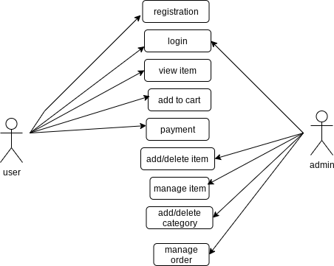

1. 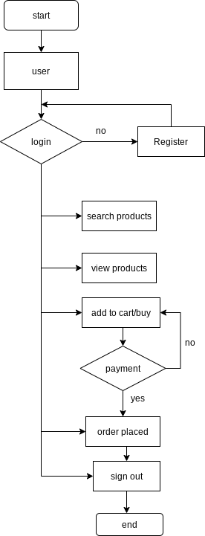**Flow Chart Diagram**

## Class Diagram

1. 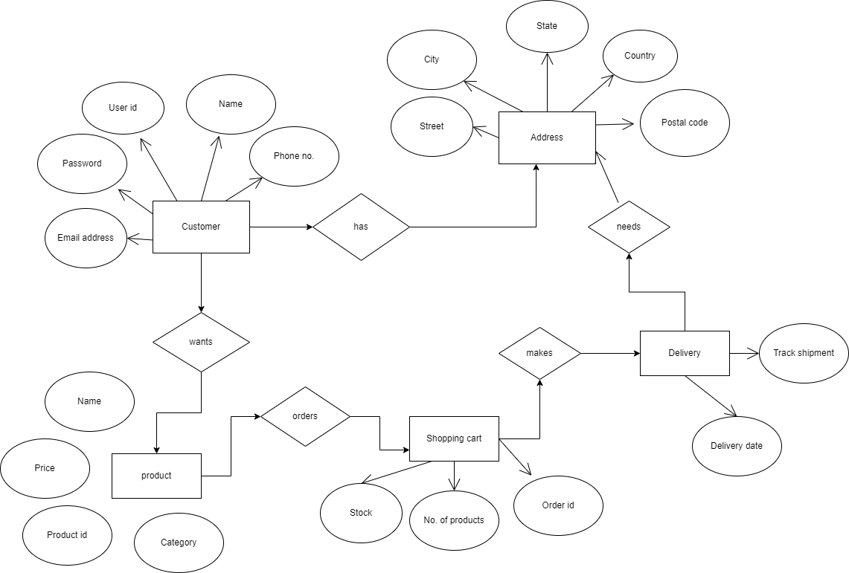**ER Diagram**